PROJECT REPORT

ON

**UBOT: YouTube Video Summarization and Question- Answering Using RAG**

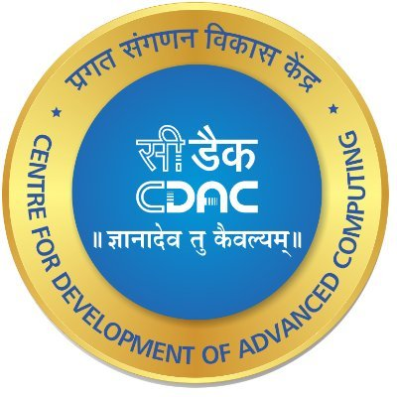ss

Submitted To: Centre for Development of Advanced Computing, Mohali

Submitted By: Sukhjot Singh, Harsh Rana, Amrit Singh

**ABSTRACT**

This report provides an overview of the summer training program on Generative AI: Fundamentals and Techniques, conducted at C-DAC, Mohali under the mentorship of Ms. Gulbadan Khehra. The training covered a wide array of topics central to modern artificial intelligence and machine learning, including Python programming, data manipulation with Pandas and NumPy, and advanced frameworks like TensorFlow and PyTorch. Key concepts such as backpropagation, convolutional neural networks (CNNs), recurrent neural networks (RNNs), long short-term memory (LSTM), gated recurrent units (GRUs), and Transformer models were thoroughly explored.

Participants gained hands-on experience with various Transformer-based models, such as BERT and GPT, delving into their architecture and applications in natural language processing tasks. The training also covered generative models like Generative Adversarial Networks (GANs) and Variational Autoencoders (VAEs), emphasizing their role in creating new data from existing datasets.

Practical sessions involved utilizing the Hugging Face models and OpenAI playground, with a focus on prompt engineering and model fine-tuning. The training also included running and managing experiments on Google Colab, leveraging its computational resources for model training and testing.

This report encapsulates the learning outcomes, practical applications, and project implementations from the training, highlighting the development of a YouTube video summarization tool as a significant application of the acquired knowledge. The tool integrates various AI and NLP techniques to automate video transcript extraction and summarization, showcasing the practical utility of the concepts learned during the training.

**ACKNOWLEDGEMENT**

I would like to take this opportunity to extend my heartfelt gratitude to all those who have been instrumental in making my summer training experience at C-DAC, Mohali, a rewarding journey.

I am profoundly grateful to Ms. Gulbadan Khehra, my mentor at C-DAC, whose guidance, support, and expertise have been invaluable throughout my training. Her mentorship not only broadened my understanding, but also inspired me to strive for excellence in the field of Applied Artificial Intelligence and Analytics.

I would also like to express my gratitude to the entire team at C-DAC, Mohali, for providing me with a conductive learning environment and entrusting me with meaningful projects and responsibilities.

Furthermore, I am grateful to my institution, Chandigarh College of Engineering and Technology, Chandigarh, for providing the necessary resources and support to undertake this training.

Finally, I am thankful to my family and friends for their constant encouragement, understanding, and support throughout this journey.

**CERTIFICATE FROM ORGANIZATION**

**LIST OF FIGURES**

Figure1: Certificate issued by organization………………………...4

Figure2: The main Entrance of C-DAC Mohali…………………….9

Figure3: Workflow for speech to text……………………………..19

Figure4: Workflow of DistilBERT for summarisation……………22

Figure5: Workflow of RAG for Question-Answering……………24

**LIST OF ABBREVIATIONS**

|  |  |  |
| --- | --- | --- |
| **S.No.** | **Abbreviations** | **Full Form** |
| 1. | RAG | Retrieval Augmented Generation |
| 2. | BERT | Bidirectional Encoder Representations Transformer |
| 3. | C-DAC | Centre for Development of Advanced Computing |
| 4. | R&D | Research and Development |
| 5. | IT | Information Technology |
| 6. | VS | Visual Studio |
| 7. | LLM | Large Language Model |

**TABLE OF CONTENT**

**PAGE NO.**

**ABSTRACT** 2

**ACKNOWLEDGEMENT** 3

**CERTIFICATE FROM ORGANIZATION** 4

**LIST OF FIGURES** 5

**LIST OF ABBREVIATIONS** 6

**CHAPTERS**

**1. COMPANY PROFILE**

1.1 About C-DAC 8 1.2 Product and Services 8

**2. INTRODUCTION**

4.1. Project Overview 10

4.2. Relevance and Importance 10

4.3. Key Highlights 11

**3. BACKGROUND**

5.1. Problem Statement1: Speech to Text 13

5.2. Problem Statement2: Summarization Using DistilBERT 13

5.3. Problem Statement3: RAG for Question-Answering 14

**4. METHODOLOGY AND WORKING**

6.1. Working 15

6.2. Workflow inside DistilBERT for Text Summarization 17

6.3. Workflow inside RAG for Question-Answering 20

6.4. Tools and Technologies Used  22

**5. OBSERVATIONS AND FINDINGS** 24

**6. LIMITATIONS**  27

**7. CONCLUSION AND FUTURE WORK**

7.1. Conclusion 28

7.2. Future Work 29

**8. REFRENCES** 31

**1. COMPANY PROFILE**

* 1. **About C-DAC**

C-DAC Mohali is a premier R&D organization under the Ministry of Electronics and Information Technology, funded by the Government of India. It focuses on advanced computing technologies to drive innovation across various domains, including IT, cybersecurity, e-governance, and healthcare. The organization’s mission is to develop cutting-edge solutions for complex challenges and collaborate with industry partners, academia, and government agencies. Its impactful research in AI, cybersecurity, and health informatics often leads to commercial products that contribute to economic growth. It also collaborates nationally and internationally to enhance knowledge exchange and address global technological challenges.

* 1. **Products and Services**

C-DAC Mohali offers a diverse range of products and services designed to cater to the needs of government, industry, and academia. These offerings include:

**1.2.1 Software Development:**

* **E-Governance Solutions:** Develops applications that streamline administrative processes, increase transparency, and improve citizen services, such as digital portals and online service delivery platforms.
* **Cybersecurity Solutions:** Provides tools and services to protect critical infrastructure and sensitive data from cyber threats, including intrusion detection systems and secure communication platforms.

**1.2.2 Consultancy Services:**

* **IT Consultancy:** Offers services to design, implement, and optimize IT infrastructure, including system integration, network design, and performance tuning.
* **Research and Development:** Engages in R&D projects with academic institutions, industry partners, and government agencies to develop innovative solutions in areas like AI, machine learning, and data analytics.

**1.2.3 Training and Education:**

* **Professional Training Programs:** Conducts training programs and workshops to enhance the skills of IT professionals and students in software development, cybersecurity, data science, and more.
* **Academic Collaborations:** Partners with universities and colleges to offer specialized courses and certification programs in advanced computing technologies.

**1.2.4 1Research and Innovation:**

* **High-Performance Computing (HPC):** Develops and deploys HPC systems to solve complex computational problems in scientific research and engineering.
* **Multilingual Computing:** Develops language processing tools and technologies to facilitate communication and information access in multiple languages.

**1.2.5 Health Informatics:**

* **Telemedicine Solutions:** Develops platforms to enable remote healthcare services and consultations, improving access to medical services in remote areas.
* **Health Management Systems:** Creates health management systems that integrate hospital management, patient care, and medical data analysis.

C-DAC Mohali’s commitment to innovation, quality, and excellence has established it as a leader in advanced computing and information technology. By continuously pushing the boundaries of technology. C-DAC Mohali aims to drive the nation’s digital transformation and develop impactful solutions for society

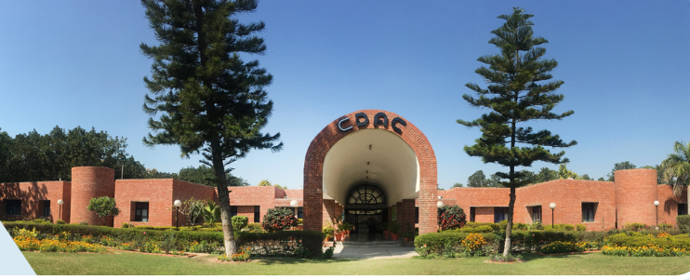

Figure 1: Main Entrance Of C-DAC, Mohali

## 2. INTODUCTION

**3.1 Project Overview:**

In today's fast-paced digital world, video content has become a predominant form of information dissemination and entertainment. With millions of videos uploaded to platforms like YouTube every day, it can be challenging for users to find and consume relevant content efficiently. Summarizing video content can significantly enhance user experience by providing concise overviews, saving time, and improving accessibility. This project aims to address this need by developing a YouTube video summarization tool that leverages advanced AI techniques.

Our project uses the **youtube_transcription_api** to retrieve transcriptions or use **speech to text conversion** transformer models to obtain transcription of YouTube videos. By obtaining the text content, we can then apply natural language processing (NLP) techniques to generate summaries. At the core of our summarization process is **DistilBERT**, a smaller, faster, and more efficient version of the BERT (Bidirectional Encoder Representations from Transformers) model. DistilBERT maintains 97% of BERT's performance while being 60% faster and smaller, making it an ideal choice for real-time applications.

The tool we developed allows users to input a YouTube video URL and receive a concise, AI-generated summary of the video's content. This summary provides an overview of the key points discussed in the video, enabling users to quickly grasp the main ideas without watching the entire video. By integrating state-of-the-art AI models and APIs, our project showcases the potential of combining NLP and video content to enhance information accessibility and user convenience.

**2.2 Relevance and Importance:**

The relevance and importance of the project lie in its potential to transform how users access and utilize information from YouTube videos. In educational settings, students and educators can quickly retrieve precise information from lectures and tutorials, making learning more efficient. Researchers can easily find relevant segments within long presentations or conferences, accelerating the research process. In the corporate sector, professionals can swiftly extract key insights from training videos, webinars, and meetings, enhancing productivity and decision-making. By overcoming the limitations of traditional keyword-based searches, this project addresses the need for contextual understanding and precise information retrieval, ultimately making vast amounts of video content more accessible and actionable.

**2.3 Key Highlights:**

**2.3.1. Integration of Advanced NLP Technologies:** The project utilizes **DistilBERT**, a powerful and lightweight model derived from BERT, to perform text summarization. DistilBERT achieves 97% of BERT’s performance while being more computationally efficient, making it well-suited for real-time applications. This integration demonstrates the practical application of cutting-edge AI technologies for content summarization.

**2.3.2. Efficient Video Transcription:** By employing the **youtube_transcription_api**, or **speech to text** transformer models, the project automatically extracts accurate and comprehensive transcripts from YouTube videos. This API provides a robust foundation for generating summaries by converting video content into structured text data that can be processed by summarization algorithms.

**2.3.3. User-Friendly Interface:** The project features a user-friendly web interface where users can simply input a YouTube video URL to receive a concise summary. This intuitive design ensures that the tool is accessible to a broad audience, including those who may not have a technical background.

**2.3.4. Time-Saving Benefits:** The summarization tool addresses a significant user need by reducing the time required to understand video content. Users can quickly read summaries to determine the relevance of videos, which is particularly beneficial for busy professionals, students, and researchers who need to manage their time efficiently.

**2.3.5. Enhanced Content Accessibility:** By providing text-based summaries, the tool improves accessibility for individuals who may have hearing impairments or those who prefer reading over watching videos. This feature aligns with broader goals of inclusivity and equal access to information.

**2.3.6. Practical Application of Generative AI:** The project showcases how generative AI models like DistilBERT can be applied to real-world problems. The successful implementation of text summarization demonstrates the potential of AI to create useful and impactful applications beyond theoretical research.

**2.3.7. Foundation for Future Enhancements:** The project lays the groundwork for future developments in video summarization and content analysis. The methods and technologies used can be expanded for other applications, such as summarizing different types of media, developing advanced recommendation systems, or improving content curation.

**2.3.8. Demonstration of End-to-End AI Workflow:** The project illustrates a complete AI workflow, from data collection (video transcription) to processing (text summarization) and presentation (summary generation). This end-to-end approach highlights the practical steps involved in deploying AI solutions and offers a comprehensive example of AI development

### **3. BACKGROUND:**

### **3.1 Problem Statement 1:**

**Speech to Text**: The increasing prevalence of voice-based applications and digital assistants has underscored the importance of accurate and efficient speech-to-text systems. However, existing speech recognition systems often struggle with challenges such as diverse accents, dialects, and background noise, leading to suboptimal performance in real-world scenarios. The motivation behind choosing this project stems from the need for a robust and adaptable speech-to-text solution capable of transcribing spoken language into written text accurately and efficiently. By developing a speech-to-text component that can be integrated into ongoing projects, this project seeks to address these challenges and provide a versatile solution that meets the diverse transcription needs across various applications and industries. The proposed approach involves optimizing transformer models and audio pre-processing techniques to enhance the transcription accuracy

**3.2 Problem Statement 2:**

**Summarization using DistilBERT**: In the digital age, the volume of video content on platforms like YouTube has exploded, making it increasingly difficult for users to extract essential information quickly. Educational, informational, and tutorial videos often span several minutes to hours, posing a challenge for viewers who need quick insights or summaries. There is a clear need for an efficient tool that can convert the spoken content of these videos into concise, readable summaries. This tool would be invaluable for students, professionals, and general users who want to save time and get the essence of a video without watching it entirely. The project aims to address this challenge by developing a YouTube Video Summarization tool that leverages advanced natural language processing (NLP) techniques, including speech-to-text conversion and text summarization models, to provide accurate and concise summaries of YouTube videos.

**3.3 Problem Statement 3:**

**RAG for Question-Answering:** The ability to accurately and effectively extract information from YouTube videos is critical in various fields, such as education, research, and corporate sectors, where extensive video content is frequently referenced. The limitations of traditional keyword-based search methods often result in imprecise or irrelevant results as they struggle to understand the context and nuance of queries. Retrieval-Augmented Generation (RAG) techniques address these limitations by integrating advanced retrieval and generation models, thereby enhancing the precision and relevance of the information retrieved. This has significant implications for improving decision-making processes, accelerating research, and increasing productivity by providing users with precise answers from video content quickly and effectively.

### **4. METHODOLOGY AND WORKING**

### **4.1 Working**

The YouTube Video Summarization Project converts video content into concise summaries using advanced NLP techniques, employing several key stages from input to output.

#### **4.1.1** **Video URL Input and Transcription Retrieval**

* **User Input:** Users input a YouTube video URL into a provided text field on the web interface.
* **API Call (YouTube Transcription API):** Upon clicking the "Generate Summary" button, the system sends a request to the **youtube_transcription_api** to fetch the video’s transcript.
* **Transcript Data:** The API returns the transcript containing the spoken words and their timestamps.

**Alternative Method: Audio Extraction and Speech-to-Text:**

* **Audio Extraction:** If the **youtube_transcription_api** is unavailable, the video’s audio is extracted.
* 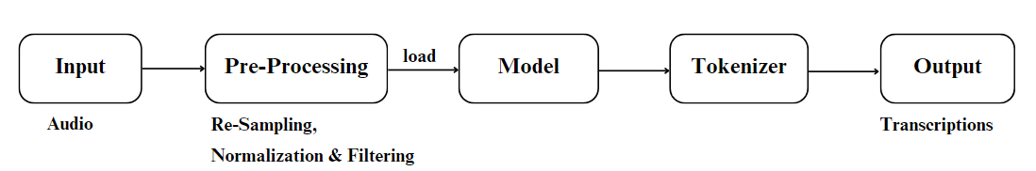**Speech-to-Text Conversion:** The extracted audio is then processed using a speech-to-text pretrained transformer model available on hugging face i.e. wav2veg2 model, to generate the transcript.

Figure 3*: Workflow for Speech-to-Text i.e. audio to transcription*

#### **4.1.2.** **Text Preprocessing**

* **Text Cleaning:** The raw transcript is cleaned to remove timestamps and extraneous information.
* **Text Normalization:** The text is converted to lowercase, special characters are removed, and grammatical errors are corrected.
* **Text Segmentation:** The cleaned text is divided into sentences or segments for easier processing.

#### **4.1.3.** **Text Summarization Using DistilBERT**

* **Model Loading:** The DistilBERT model is loaded from the Hugging Face library.
* **Tokenization:** The text segments are tokenized into input IDs using the DistilBERT tokenizer.
* **Summarization:** The tokenized inputs are fed into DistilBERT, which generates a summary by identifying and focusing on the most important sentences.

### **4.1.4. Question Answering Using Retrieval-Augmented Generation (RAG)**

* **Embeddings Initialization**: The HuggingFaceEmbeddings model is initialized to convert text segments into embeddings.
* **Text Splitting and Indexing**: The transcript is split into manageable chunks and indexed using FAISS for efficient retrieval.
* **Retriever Setup**: A retriever is set up to search for the most relevant chunks of text based on user queries.
* **RAG Chain Configuration**: A RAG chain is configured using a Cohere language model and a prompt template to generate precise answers from the retrieved text.
* **Question Handling**: When a user submits a question, the RAG system retrieves relevant context from the indexed chunks and generates an accurate answer using the language model.

### **4.1.5. Summary Generation and Presentation**

* **Summary Formatting**: The generated summary is formatted to ensure readability.
* **Display**: The summary is displayed on the web page, allowing users to easily read and understand the video’s content.
* **Answer Display**: When a user asks a question, the generated answer is displayed on the web page, providing precise information based on the video content.

By combining summarization and question answering, this project enhances the accessibility and usability of YouTube video content, making it easier for users to extract and understand relevant information quickly and effectively.

### **4.2 Workflow Inside DistilBERT for Text Summarization:**

The **DistilBERT** model is a streamlined version of BERT (Bidirectional Encoder Representations from Transformers) designed to be faster and more efficient while maintaining high performance for various NLP tasks. The following sections outline the detailed workflow inside DistilBERT for text summarization, from input text to generating a summary.

### **4.2.1. Text Input and Tokenization**

**Description:** The text input for summarization is first tokenized into manageable chunks. Tokenization is the process of converting raw text into a format that the model can understand.

**Workflow:**

* **Text Tokenization:** The input text is split into tokens, which are the smallest units of text such as words or sub-words.
* **Token IDs:** Each token is mapped to a unique integer ID based on the DistilBERT tokenizer's vocabulary.

**Technical Details:**

* **Tokenizer:** DistilBERT uses the DistilBertTokenizer class from the Hugging Face transformers library.

### **4.2.2**. **Input Representation**

**Description:** The tokenized text is converted into input representations that DistilBERT can process.

**Workflow:**

* **Input Embeddings:** Tokens are converted into embeddings, which are dense vector representations capturing semantic meanings.
* **Add Special Tokens:** Special tokens like [CLS] for classification and [SEP] for separation are added.

**Technical Details:**

* **Embedding Layer:** The DistilBertModel class processes the token IDs to generate embeddings.

### **4.2.3. Self-Attention Mechanism:**

**Description:** The self-attention mechanism allows the model to weigh the importance of different tokens relative to each other.

**Workflow:**

* **Attention Calculation:** Each token's representation is updated based on the weighted sum of other tokens' representations.
* **Contextual Embeddings:** This mechanism generates contextual embeddings for each token, capturing relationships and dependencies in the text.

**Technical Details:**

* **Attention Weights:** The model computes attention scores using query, key, and value matrices.

### **4.2.4. Feature Extraction and Pooling**

**Description:** After self-attention, the model extracts features from the contextual embeddings for summarization.

**Workflow:**

* **Feature Extraction:** Features are extracted from the final hidden states of the tokens.
* **Pooling:** Typically, features from the [CLS] token are used for summarization tasks.

**Technical Details:**

* **CLS Token:** The embedding of the [CLS] token, which represents the aggregated information of the text, is used.

### **4.2.5.** **Text Summarization**

**Description:** The features are then used to generate a summary of the text.

**Workflow:**

* **Summarization Head:** A summarization model processes the features to produce a summary.
* **Text Generation:** The model generates a summary by selecting the most relevant information from the features.

**Technical Details:**

* 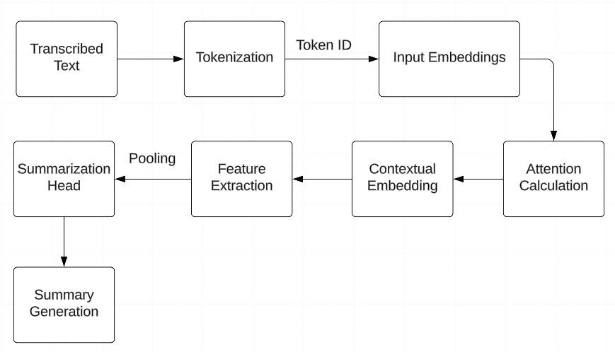**Text Generation:** Text generation is done through a decoder layer in models like Bart or T5, which can be applied for summarization. DistilBERT itself is used primarily for encoding, and summarization might involve additional layers.

Figure 2: Workflow inside DistilBERT for summarization

## 4.3 Workflow Inside RAG for Question Answering:

The RAG model integrates retrieval and generation components to provide precise and contextually relevant answers based on the video transcript. The following sections outline the detailed workflow inside RAG, from input text to generating an answer.

### **4.3.1. Data Upload and Information Extraction**

* **Description**: The system starts by extracting and preparing the video transcript for further processing.
* **Workflow**:
  + **Transcript Retrieval**: The transcript of the YouTube video is fetched using the YouTube Transcription API or by processing the audio.
  + **Text Extraction**: The spoken words from the video are converted into a textual format.

### **4.3.2. Chunking**

* **Description**: The extracted text is segmented into smaller, manageable chunks to facilitate efficient processing.
* **Workflow**:
  + **Text Segmentation**: The text is divided into chunks or sections to enable better handling and analysis.
* **Technical Details**:
  + **Text Splitter**: Utilizes RecursiveCharacterTextSplitter for dividing the text into chunks with specified chunk size and overlap.

### **4.3.3. Embedding Generation**

* **Description:** The text chunks are converted into embeddings, which are dense vector representations that capture the semantic meaning of the text.
* **Workflow**:
  + **Embedding Conversion**: Text chunks are transformed into embeddings using a pre-trained model.
* **Technical Details**:
  + **Model**: Uses HuggingFaceEmbeddings with the model sentence-transformers/all-MiniLM-L6-v2.

### **4.3.4. Vector Store Implementation**

* **Description**: The generated embeddings are stored in a vector store for efficient similarity searches.
* **Workflow**:
  + **Storage**: Embeddings are indexed and stored in a vector store like FAISS (Facebook AI Similarity Search).
* **Technical Details**:
  + **Vector Store**: Implements FAISS for managing and searching embeddings based on vector similarity.

### **4.3.5. Query Processing and Retrieval**

* **Description**: When a user submits a question, it is processed to retrieve relevant text chunks from the vector store.
* **Workflow**:
  + **Query Embedding**: The user's question is converted into an embedding.
  + **Similarity Search**: The query embedding is compared with stored embeddings to retrieve the top ‘k’ most similar text chunks.
* **Technical Details**:
  + **Retriever**: Uses the vector store's search functionality to find relevant passages based on embedding similarity.

### **4.3.6. Answer Generation**

* **Description**: The retrieved text chunks and the user's question are passed to a generative model to produce an answer.
* **Workflow**:
  + **Contextual Answering**: The retrieved text chunks are used as context to generate an answer to the user's question.
* **Technical Details**:
* **Generative Model**: Utilizes a language model (e.g., Cohere's command model) to generate coherent and contextually accurate answers based on the provided context.

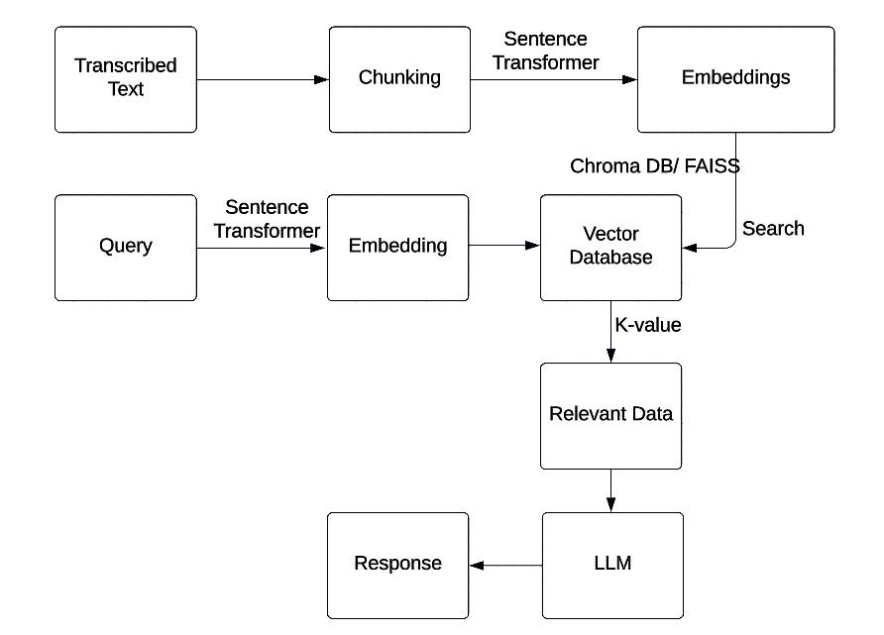

**4.4 Tools and Technology Used**

Figure 3:Workflow of RAG for Question Answering

**4.4.1** **Frontend Technologies:**

* **HTML:** For structuring the web interface.
* **CSS:** For styling the user interface.
* **JavaScript:** For client-side scripting to handle interactions and dynamic content.

**4.4.2** **Backend Technologies:**

* **Python:** The primary language for backend development.
* **Flask:** A web framework for building and serving the application.

**4.4.3** **Machine Learning and AI:**

* **Langchain Framework:** Implements RAG and leverages its NLP functionalities for text processing and integration.
* **Hugging Face Transformers Library:** Utilized for both retrieval and generation models.
  + **RAG (Retrieval-Augmented Generation):** Combines a retriever and a generator to answer questions based on external documents.
  + **Retriever Model:** For fetching relevant documents from a corpus.
  + **Generator Model:** For generating answers based on the retrieved documents.
* **Chunk-Embedding Generation:** Creates embeddings for text chunks using state-of-the-art embedding techniques like Sentence Transformers to capture semantic similarities and relationships within the text.
* **Vector Store Implementation:** Utilizes vector stores like Chroma DB and FAISS to efficiently store, index, and retrieve embeddings, supporting vector similarity search algorithms to find relevant passages based on query embeddings.
* **Open-Source Large Language Models (LLM):** Integrates pre-trained LLMs from the Hugging Face Transformer library, such as Mistral, Zephyr-7B-alpha, Llama, or Ollama, to generate contextually relevant responses to user queries, with potential fine-tuning for domain specificity.

**4.4.4** **Development and Deployment:**

* **VS Code:** Used for code development, debugging, and version control, providing a comprehensive environment for project development.
* **Google Colab:** Used for running experiments, training models, and accessing GPU resources, facilitating efficient model training and testing.
* **VS Code:** For development and debugging.
* **Local Development Environment:** For building and testing the application.

**4.4.5** **APIs and External Services:**

* **YouTube Data API:** For fetching YouTube video details and transcripts.

**5. OBSERVATIONS AND FINDINGS**

**5.1 Observations:**

### **5.1.1 Effectiveness of RAG Integration**

* The seamless integration of retrieval and generation components within the RAG architecture significantly enhanced information retrieval accuracy and relevance. This synergy allowed for more precise answers, as the retrieval component ensured relevant context was fetched, while the generation component effectively used this context to generate coherent and relevant responses.

### **5.1.2 Performance Variation with Video Complexity**

* **Complexity and Length:** The system's performance varied based on the complexity and length of the videos processed. Longer videos resulted in increased response times due to the additional processing required to handle and analyze extensive content.
* **Content Variety:** Videos with diverse content, such as mixed media, multiple speakers, and varying topics, posed challenges in accurately extracting, summarizing, and generating information, leading to potential inaccuracies in the generated summaries and answers.

### **5.1.3 Impact of Query Variability**

* **Query Type:** Different types of queries (e.g., factual, descriptive, analytical) affected the system's performance. Factual queries generally yielded more precise answers, while descriptive and analytical queries sometimes resulted in less specific responses.
* **Phrasing and Context:** Variations in query phrasing and context influenced the system's ability to retrieve and generate relevant answers. Queries with clear and concise phrasing performed better, while ambiguous or contextually complex queries sometimes led to less accurate responses.

### **5.1.4 Summarization Quality**

* **Coherence:** The summaries generated were generally coherent, with the system effectively condensing the video content into a structured format.
* **Completeness:** The system successfully provided complete summaries for straightforward videos but occasionally struggled with more complex videos that required synthesizing information from multiple segments.
* **Relevance:** Most summaries were relevant and captured the key points of the videos, but there were instances where the system missed some nuanced details, leading to less comprehensive summaries.

### **5.1.5 Generated Response Quality**

* **Coherence:** The generated answers were generally coherent, with the RAG architecture ensuring logical flow and structure in the responses.
* **Completeness:** The system successfully provided complete answers for straightforward queries but occasionally struggled with more complex queries that required synthesizing information from multiple parts of the video.
* **Relevance:** Most responses were relevant to the queries, but there were instances where the system's understanding of the query context was limited, leading to less relevant answers.

### **5.1.6 Challenges and Limitations**

* **Processing Long Videos:** Handling and processing long and complex video was time-consuming and sometimes resulted in delays.
* **Query Understanding:** The system occasionally struggled with understanding nuanced or contextually rich queries, leading to less accurate responses.
* **Content Variety:** Videos with multiple speakers, mixed media, or rapid topic changes posed challenges in accurately extracting, summarizing, and generating information.

### **5.1.7 Future Enhancements**

* **Improved Video Handling:** Implementing more advanced techniques for handling long and complex videos, including better preprocessing and efficient indexing strategies.
* **Enhanced Query Understanding:** Leveraging more sophisticated natural language understanding models to improve the system's ability to comprehend and respond to nuanced queries.
* **Optimized Response Generation:** Fine-tuning the generation models to produce more contextually relevant and specific answers, particularly for complex queries.
* **Advanced Content Recognition:** Developing methods to better handle videos with diverse content, ensuring accurate information extraction, summarization, and representation.

**6. LIMITATIONS**

**6.1 Processing Long and Complex Videos:**

* Handling long and complex videos is time-consuming and often results in increased response times. This can lead to delays in generating summaries and answers, affecting the user experience.

**6.2 Accuracy of Summarization and Answer Generation:**

* While the system generally produces coherent and relevant summaries and answers, there are instances where the output may lack accuracy, especially for videos with complex content or multiple topics. The system may miss nuanced details, leading to incomplete or less comprehensive summaries.

**6.3 Content Variety and Format:**

* Videos with diverse content, such as mixed media, multiple speakers, or rapid topic changes, pose challenges for accurate information extraction and summarization. The system may have difficulty maintaining coherence and relevance in these scenarios.

**6.4 Handling Complex Formatting and Mixed Media:**

* Videos that include complex formatting, such as embedded text, graphics, or interactive elements, can be difficult for the system to process accurately. This limitation affects the quality of the extracted and summarized information.

**6.5 Resource Intensive:**

* Accessing embedding and LLM models requires API access, which may incur costs, while using Hugging Face APIs expire after certain period, and therefore requires renewal or creating new keys.

**6.6 Limited Language Support:**

* It primarily supports English and may have limited effectiveness for other languages. Expanding language support requires additional resources and model training.

### **7. CONCLUSION AND FUTURE WORK**

**7.1 Conclusion:**

The project effectively demonstrated the capabilities of DistilBERT for summarization and RAG for question-answering within the context of YouTube video content. **DistilBERT** provided concise and coherent summaries of video transcripts, capturing the essential information from the content. **RAG** facilitated accurate and contextually relevant question-answering by integrating retrieval and generation components, which enhanced the system's ability to address user queries based on the video content.

**Key achievements** of the project include:

* **Effective Summarization:** DistilBERT delivered summaries that were generally coherent and relevant, distilling complex video transcripts into accessible and informative summaries.
* **Robust Question-Answering:** RAG demonstrated the potential for combining retrieval-based approaches with generative models to produce precise and contextually relevant answers to user queries.
* **User Engagement:** The project provided a user-friendly interface that allowed users to generate summaries and obtain answers from YouTube videos, highlighting the practical application of advanced NLP techniques.

Despite these achievements, the project faced several **limitations**:

* **Long Video Processing:** Handling and processing long videos resulted in increased response times and performance challenges.
* **Complex Query Understanding:** The system occasionally struggled with understanding nuanced queries, which impacted the accuracy of generated responses.
* **Content Variety Challenges:** Videos with diverse content types or complex formatting posed difficulties in maintaining the coherence and relevance of summaries and answers.

### **7.2 Future Work:**

To address these limitations and further enhance the capabilities of the summarization and question-answering system, the following future work is proposed:

**7.2.1 Advanced Summarization Techniques:**

* **Explore New Models:** Investigate more advanced summarization models beyond DistilBERT, such as T5 or Pegasus, to improve the quality and accuracy of video summaries.
* **Multi-Stage Summarization:** Develop a multi-stage summarization approach that first generates an overview summary and then refines it into more detailed summaries.

**7.2.2 Enhanced Query Understanding:**

* **Advanced NLP Models:** Integrate more sophisticated NLP models for better query understanding and context handling, potentially using models like BERT or GPT-4 for improved accuracy.
* **Contextual Query Expansion:** Implement methods for expanding and refining user queries to better capture the nuances of the questions and improve answer relevance.

**7.2.3 Improved Video Processing and Analysis:**

* **Efficient Processing Techniques:** Develop techniques to handle long videos more efficiently, such as breaking down videos into smaller chunks or improving transcript generation methods.
* **Content Analysis:** Enhance methods for analyzing diverse content types, including mixed media and varying speaker dynamics, to improve summarization and information retrieval.

**7.2.4 Scalability and Performance Optimization:**

* **System Architecture Improvements:** Optimize system architecture for better scalability and performance, focusing on efficient data handling, processing, and retrieval methods.
* **Load Balancing:** Implement load balancing techniques to manage high volumes of video processing and user queries.

**7.2.5 Expanded Language Support:**

* **Multilingual Capabilities:** Extend the system's language capabilities to support multiple languages for summarization and question-answering, including training models on diverse linguistic datasets.

**7.2.6 User Interface Enhancements:**

* **Interactive Features:** Improve the user interface to provide more interactive features, such as query refinement options, summary adjustments, and real-time feedback mechanisms.
* **User Guidance:** Add features for users to get more guidance on generating queries and understanding summaries, enhancing overall user experience.

**7.2.7 Integration with External Knowledge Bases:**

* **Knowledge Integration:** Incorporate external knowledge bases to enrich the retrieval process and provide more comprehensive and contextually relevant answers to user queries.

**7.2.8 Real-Time Processing Capabilities:**

* **Live Summarization and QA:** Develop capabilities for real-time video summarization and question-answering, focusing on low-latency performance for live video streams.

**7.2.9 Advanced Content Recognition:**

* **Formatting and Media Analysis:** Implement methods to better recognize and process complex video content, including advanced techniques for handling embedded text, graphics, and interactive elements.

**8. REFRENCES**

[1]L. Monigatti. “Retrieval-Augmented Generation (RAG): From Theory to Langchain Implementation.” Medium. Accessed: Apr. 15, 2024. [Online]. Available: <https://towardsdatascience.com/retrieval-augmented-generation-rag-from-theory-to-langchain-implementation-4e9bd5f6a4f2>

[2] NexaNodeLabs. “RAG Systems: An Innovative Approach to Question-Answering.” Medium. Accessed: Apr. 19, 2024. [Online]. Available: <https://medium.com/@nexanodelabs/rag-systems-an-innovative-approach-to-question-answering-1a1447472a66>

[3] “Q&A with RAG.” Langchain. Accessed: Apr. 26, 2024. [Online]. Available: <https://python.langchain.com/v0.1/docs/use_cases/question_answering/>

[4] I. Saidi. “Question Answering Over Your PDF Files in Langchain.” Medium. Accessed: May 2, 2024. [Online]. Available: <https://ibrahimsaidi.com.au/question-answering-over-your-pdf-files-in-langchain-1d0c85e65aa5>

[5] R. Ghosh. “Complete Introductory Guide to Speech to Text with Transformers.” Analytics Vidhya. Accessed: Feb. 10, 2024. [Online]. Available: <https://www.analyticsvidhya.com/blog/2023/07/speech-to-text-with-transformers/>

[6] “Automatic Speech Recognition.” Hugging Face. Accessed: Feb. 17, 2024. [Online]. Available: <https://huggingface.co/tasks/automatic-speech-recognition>

[7] “Automatic speech recognition with a pipeline.” Hugging Face. Accessed: Feb. 17, 2024. [Online]. Available: <https://huggingface.co/tasks/automatic-speech-recognition>